# SCHOOL OF COMPUTER SCIENCE AND ENGINEERING DEPARTMENT OF INTELLIGENT SYSTEM

**LOVELY PROFESSIONAL UNIVERSITY, JALANDHAR**

## FORMAT FOR PREPARING END TERM PROJECT REPORT

The purpose of the report is to explain overall working of the project. The report should contain an account of the activity for whole of project and as well as implementation of its working.

1. First Page (Appendix 1)
2. Declaration Page (Appendix 2)
3. Table of Contents (Appendix 3)
4. Bonafide Certificate for Supervisor Signature and Details (Appendix 4)
5. Background and objectives of the project assigned.

An introductory description (2-3 pages) of the project with respect to: Background, motivation and outcome of project and concrete goals and objectives.

1. Description of Project

The students are required to provide description in terms of modules and prepare pictorial flow of project.

1. Description of Work Division in terms of Roles among Students.

Here students are required to explain the work done by each student for roles allotted in MTE report. 8. Implementation of scheduled work of Project

The students are required to provide implementation of project in terms of its working and provide screenshots of designed web pages with proper explanation.

1. Technologies and Framework to be used.

The students are required to mention the technology and platform to be used in project.

1. SWOT Analysis achieved in project.

Include an analysis of project in terms of Strengths, Weaknesses, Opportunities and Threats. Strengths and weaknesses refer to the internal capabilities of the project, i e are under its control, and should be regarded relative to competitors, whereas opportunities and threats are found in the external environment, usually outside the control of the project.

Typing Instructions:

The impression on the typed copies should be black in color. One and a half spacing should be used for typing the text, and shall be typed in the Font style ‘Times New Roman’ and Font size 12, unless otherwise stated explicitly.

## APPENDIX 1

**TITLE OF PROJECT**

END TERM REPORT

***by***

**R.Shiva gowri,Prabhat pusp,Sudhakar Pandey**

Section: K19BY

Roll Number(s):

46,47,48



**Department of Intelligent Systems School of Computer Science Engineering Lovely Professional University, Jalandhar**

April-2020

## APPENDIX 2

**Student Declaration**

This is to declare that this report has been written by me/us. No part of the report is copied from other sources. All information included from other sources have been duly acknowledged. I/We aver that if any part of the report is found to be copied, I/we are shall take full responsibility for it.

<<Signature of Student>>

<<Name of Student>>

<<Roll number: >>

<<Signature of Student>>

<<Name of Student>>

<<Roll number: >>

Place Date

**APPENDIX 3**

(A typical specimen of table of contents)

**TABLE OF CONTENTS**

**TITLE PAGE NO.**

|  |  |
| --- | --- |
| **1. Background and objectives of project assigned ................** | **1** |
| **1.1** ........................................................................................ | 1 |
| **1.1.1 ....................................................................................** | **3** |
| **1.1.2 .....................................................................................** | **5** |
| **1.2 .........................................................................................** | 7 |
| **1.2.1 .....................................................................................** | **7** |
| **1.2.2 .....................................................................................** | **9** |
| **1.2.3 .....................................................................................** | **10** |
| **2 Description of Project ... ........................................................** | **14** |
| **2.1 ..........................................................................................** | **17** |
| **2.2 ..........................................................................................** | **18** |

**1) Background and objectives of project assigned.**

* 1. **Project Assigned:**

**Sport’s Club:**

**What is a Sport’s Club (About Us)?**

What began as an opportunity to bring the immensely popular sport of squash to the New York masses has evolved and expanded to a network of over 150 clubs catering to over half a million members across eight states and two countries (including Switzerland!). Dedicated to offering our members the best possible experience, we’ve proudly been at the forefront of fitness for over four decades while still maintaining that familiar, neighborhood feel.

**Benefits of Sport’s.**

Sport **clubs** provide children and youth an opportunity to learn life skills that will assist them in school as well as future careers and personal relationships. By engaging in **sports**, they learn leadership, teamwork, problem-solving, responsibility, self-discipline and a sense of initiative.

**Objective of the project:**

It is important that whatever vision and mission is developed, it reflects the aspirations of the stakeholders. A vision statement should illustrate what the sporting organization wants to become in the future. For example, a vision statement may be: 'Our vision is to be recognized as a world leader'. A vision statement is the first step in the strategic planning process followed closely by the development of a mission statement.

**2) Description of Project**

**\*The Name of our website is “GTX-The sky is the limit”.**

**2.1 HOMEPAGE:**

**2.1.1 HEAD:**

**CODE**

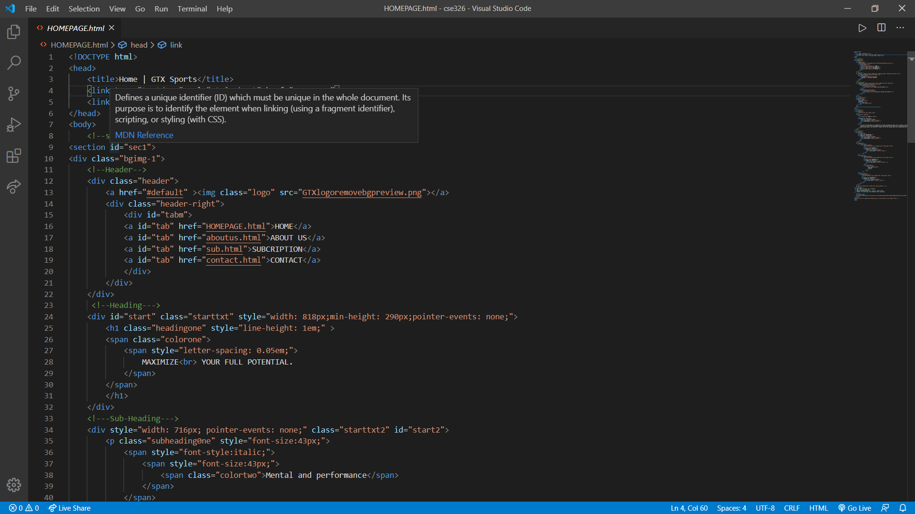

**RESULT:**

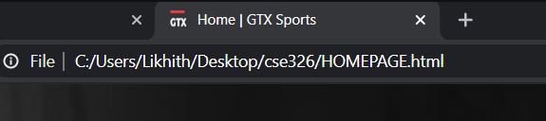

**DESCRIPTION:**

<head> ~ This is the element that contains all the metadata of the webpage.

<title> ~ Used to define the title of the webpage as shown in the result.

<link> ~ Used to link external documents such as stylesheets javascripts.etc

Here we have linked LOGO which is displayed in Title

And Two other Stylesheets which will be described.

**2.1.2 HEADER:**

**CODE**

**HTML**

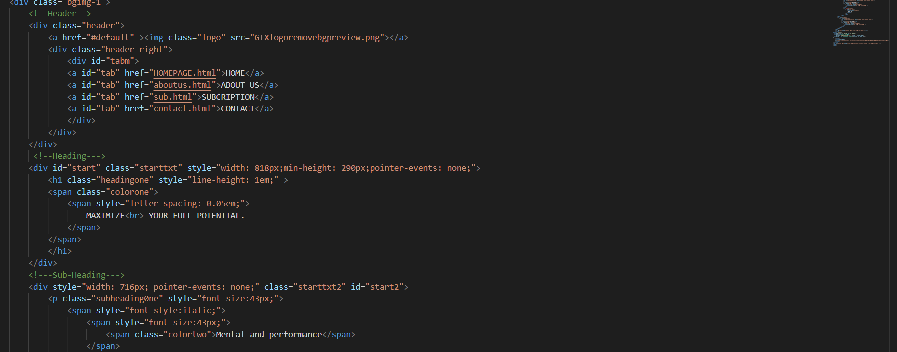

**CSS**

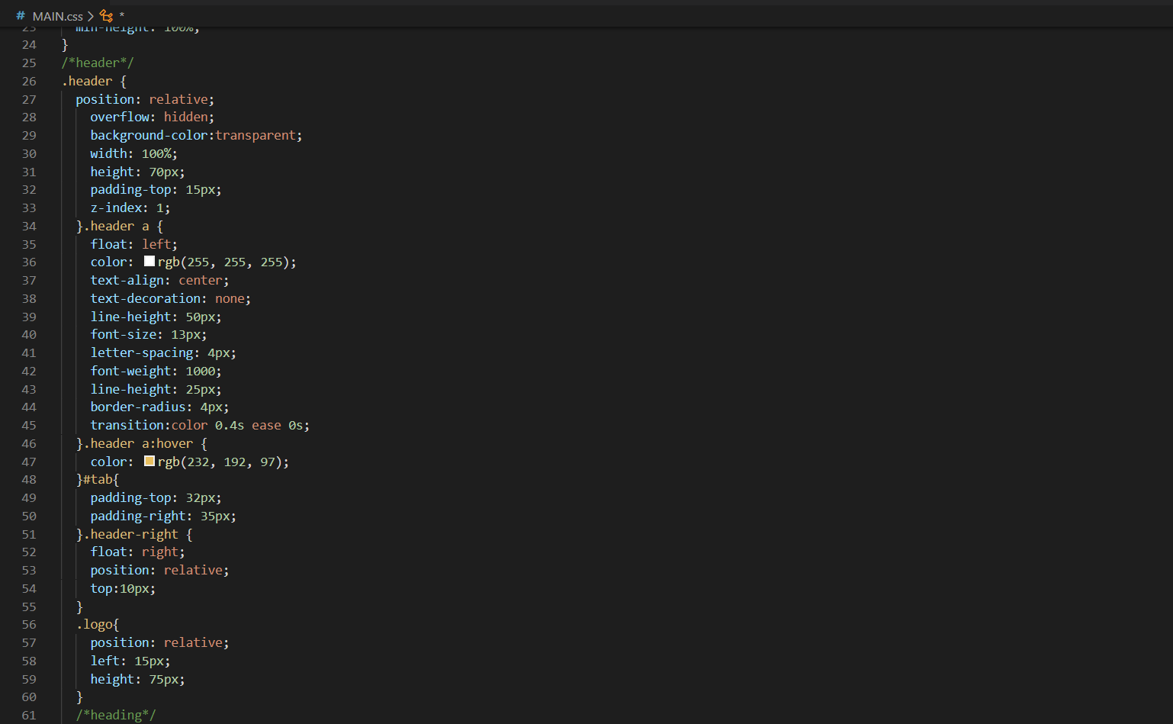

**RESULT:**



**DESCRIPTION:**

<input> ~ Specifies an input field where the user can enter data.

<a> ~ Used to define the beginning and end of a hypertext link.

<i> ~ To insert an icon

Transform ~ Property lets you rotate, scale, skew, or **translate** an element

When the search icon is Hovered it expands showing the search field.

The search field is been made using <form>.

Company logo is aligned to left.

**2.1.3 IMAGE-SLIDER:**

**CODE**

**HTML**

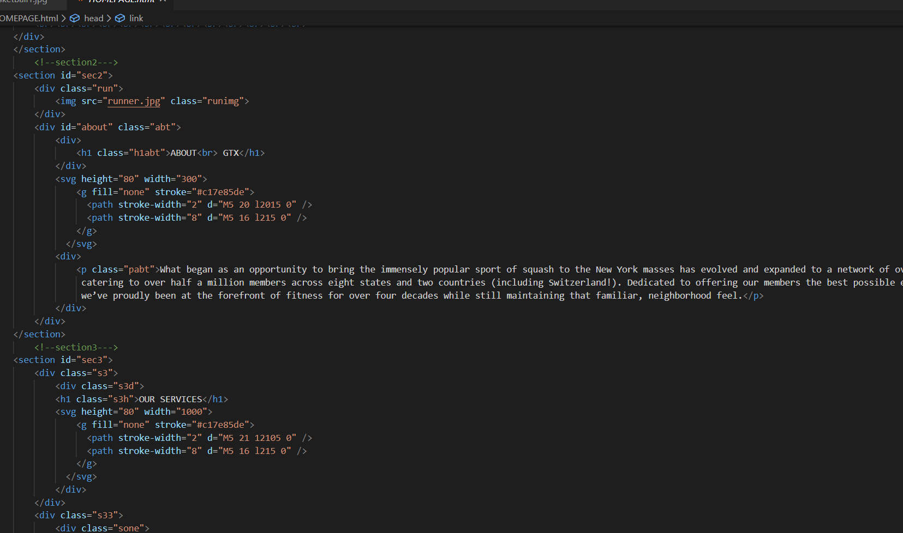

**CSS**

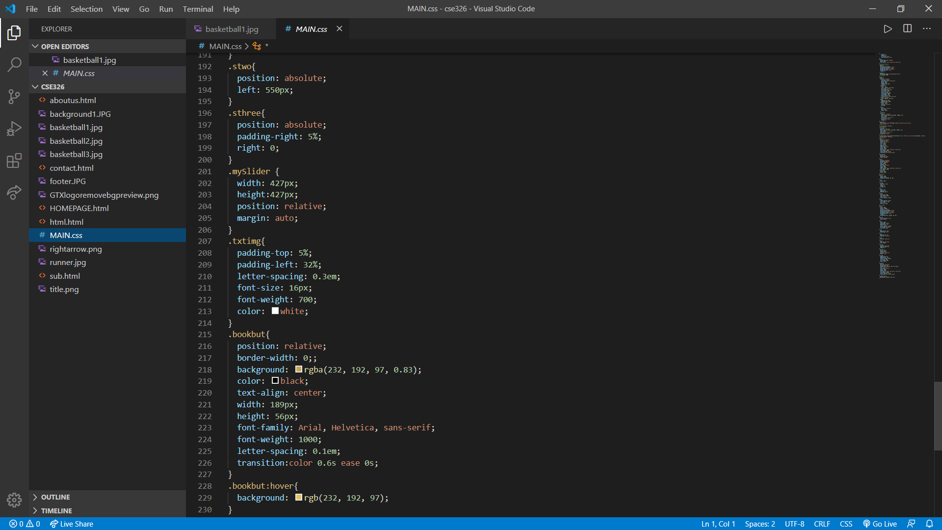

**RESULT**



**DESCRIPTION:**

Animation ~ lets an element gradually change from one style to another.

nth-child ~ The :nth-child(*n*) selector matches every element that is the *n*th child, regardless of type, of its parent.*n* can be a number, a keyword, or a formula.

Animation-delay ~ property specifies a delay for the start of an animation

We have created a responsive slider using css and html with the help of above tags.

**CODE**

**HTML**

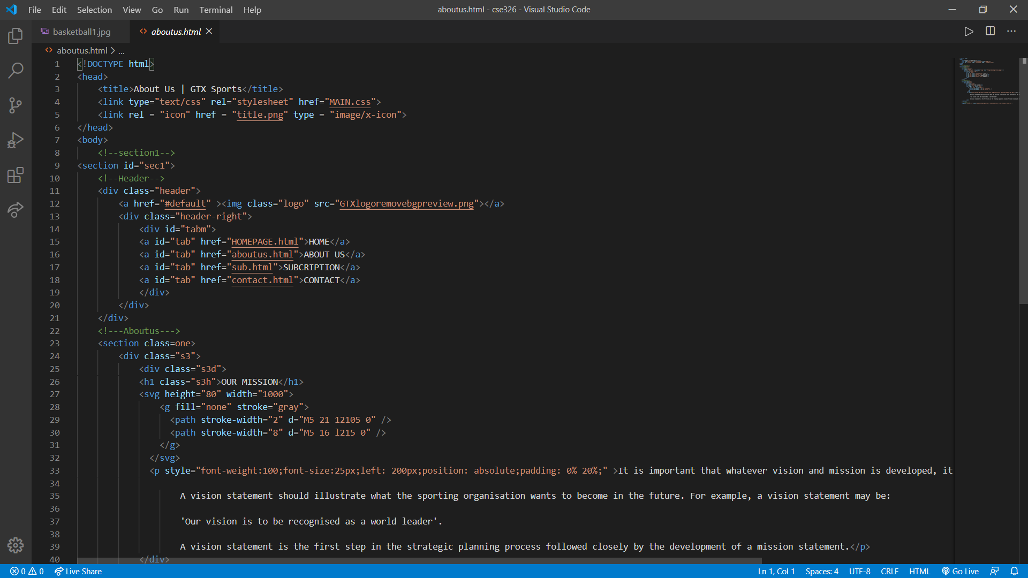

**2.2 CONTACT US:**

**2.2.1 BOOK A SLOT FORM:**

**CODE**

**HTML**

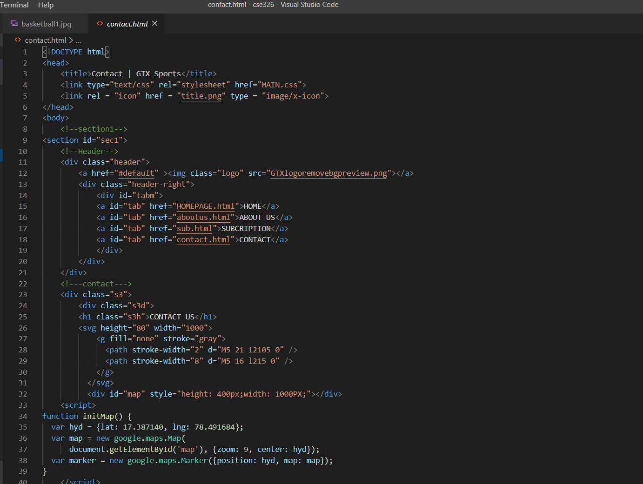

**RESULT**

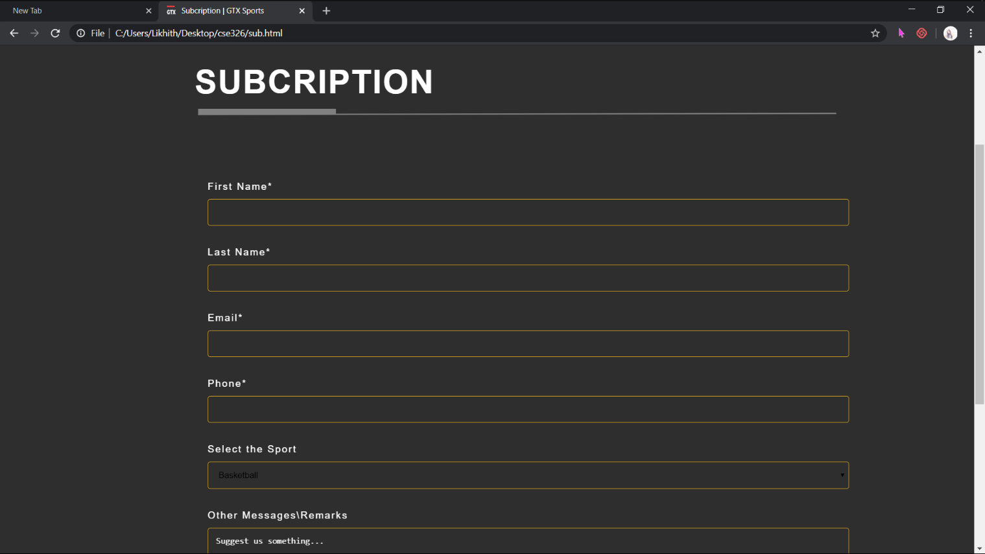

**DESCRIPTION**

We have used form tag and different type of input tags to make the above booking form.



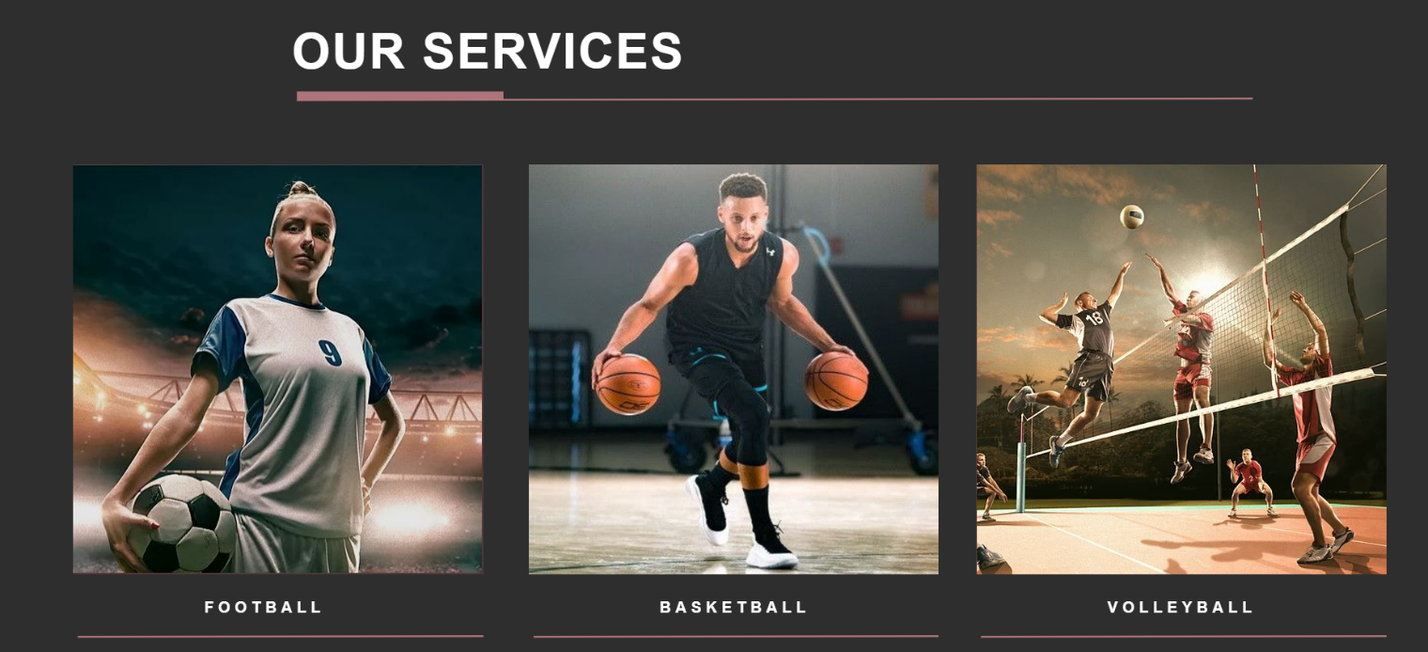

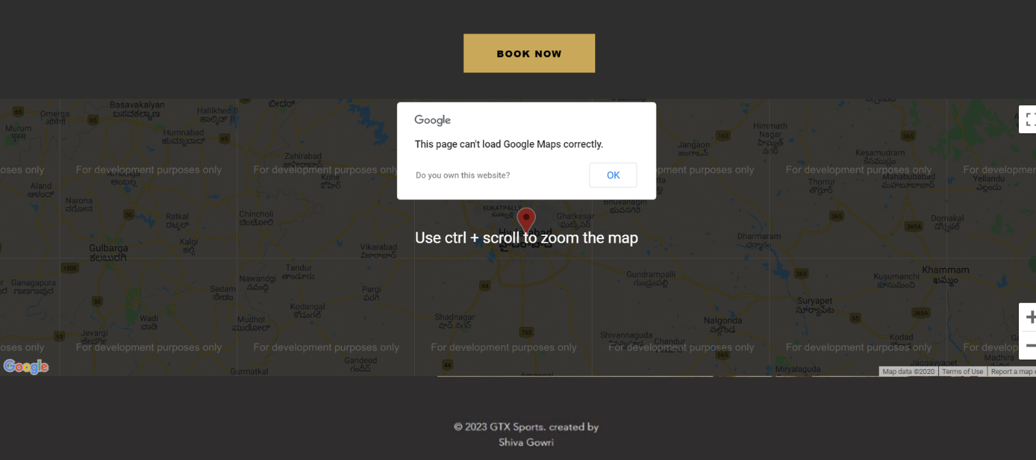

**2.3 ROLE AND RESPONSIBILTY:**

**Sudhakar**: Selecting logo and HTML

**R. Shiva Gowri**: Writing CSS AND HTML

**Prabhat**: Assisting in HTML and Correcting all Errors

**2.4 Technologies and Framework Used:**

**HTML**

**CSS**

**JAVASCRIPT**

**2.4.1 SOFTWWARE USED:**

**VISUAL STUDIO CODE**

**SUBLIME TEXT**

APPENDIX 4

BONAFIDE CERTIFICATE

Certified that this project report “……….TITLE OF THE PROJECT… ” is the

bonafide work of “Sehaj Kapoor, P.Tarun, Deepak” who carried out

the project work under my supervision.

### <<Signature of the Supervisor>>

<<Name of supervisor>>

<<Academic Designation>>

<<ID of Supervisor>>

<<Department of Supervisor>>